學號： 姓名：
1. Consider the following BJT’s circuit,
  - Find 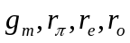 , in the case of 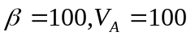
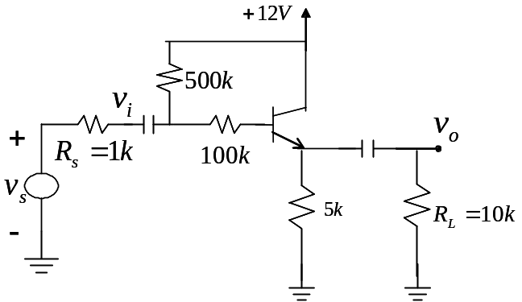
  - Find 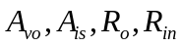.
- Consider the following CE configuration BJT’s circuit,
  - Find 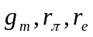 , in the case of 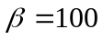
  - Find
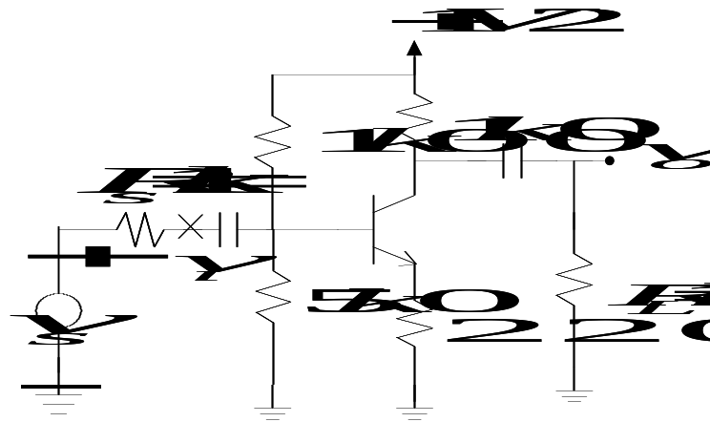
- Cascade the following two amplifiers,
  - Choose a best connect scheme in the following cascade scheme and explain your reason.
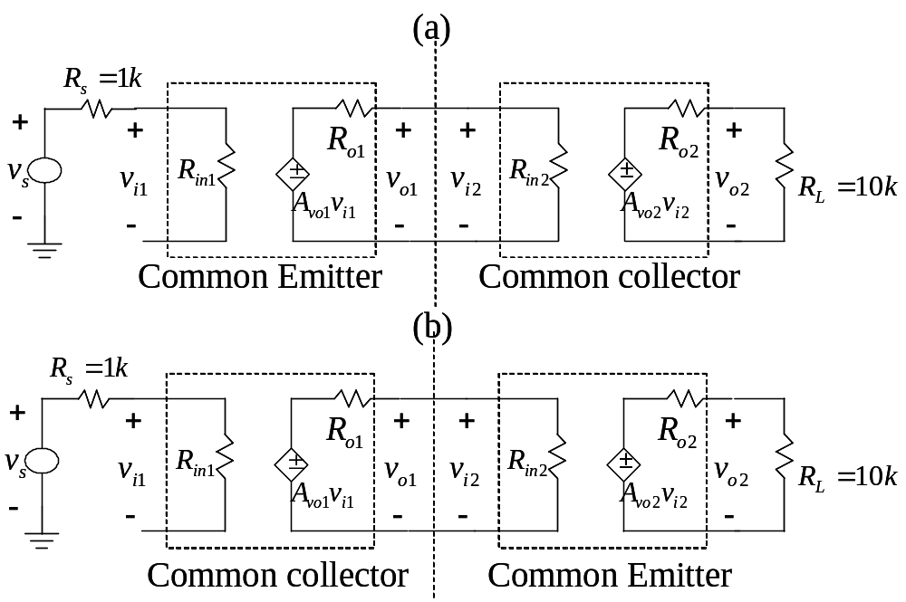
  - Find the overall voltage gain 

